**HUMAN RESOURCE MANAGEMENT**

**Dr. Hussain Alqatifi**

**JOB ANALYSIS PROJECT**

**NAME: Fahad Majid Abalkhail**

**STUDENT ID: 438104130**

**SECTION: 74000 ( 1-2:20 )**

**INDUSTRY:**

**The employee I’m interviewing works in Gaming and E-SPORTS industry, E-SPORTS getting bigger and bigger each day in the world it started with small group of players who gather and compete with each other for fun but there are a very good players who don’t get recognized those players started there own tournaments with small amount of prizes then it started to get bigger between players and common thing to win money from your PC, PS4…etc.**

**In the beginning of 2000’s this all started to happen with the blooming of technology around the world and that everyone can afford a video game or a device companies started to notice that the gaming industry is big and have a potential so they invested in E-SPORTS and started to make there own teams like Redbull or sponsoring other teams.**

**In 2010’s the big jump happened individuals and companies making millions out of the tournaments that happen like Riot games world championship the winner award is 25 million dollar without the other revenue that comes from advertisements, attendance…etc.**

**Today in 2020 Global E-SPORTS net worth is 1.1 billion dollar with 15% increase in every year, the predictions says that in 2023 it will be 1.5 billion dollar.**

**COMPANY:**

**Challenge Arena started in 2014 as a Gaming café only the plan from the foundation of the company is to lead the MENA Region on E-SPORTS and the gaming cafe was a good approach to the community and the companies. Now they have a legal License and it is the first Gaming café license issued in Saudi Arabia was for Challenge arena.**

**Challenge Arena now organize tournaments for “AAA” companies like Blizzard and Riot Games in MENA region.**

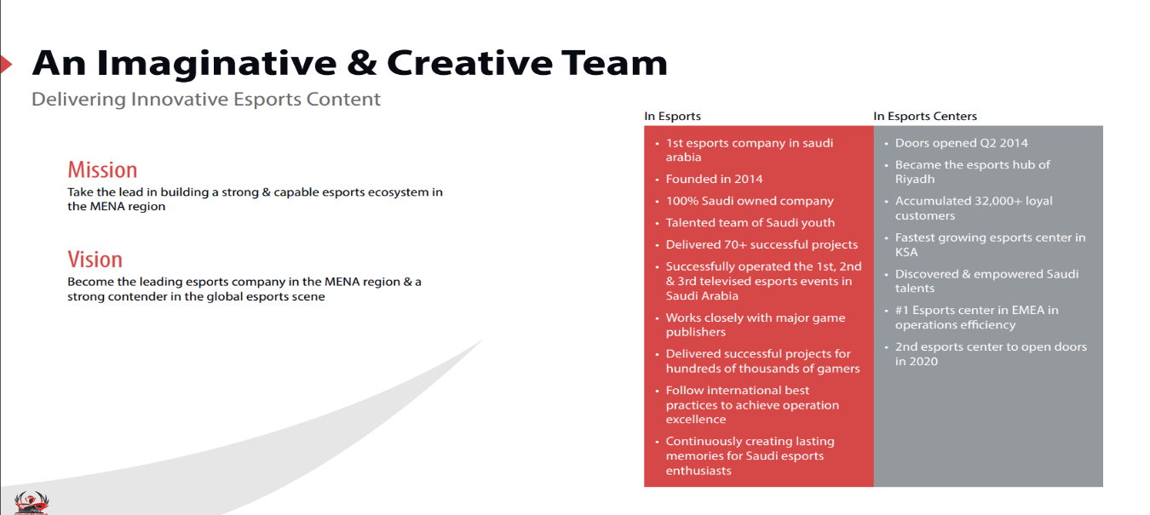

**JOB TITLE:**

**Project Management I choose this employee specifically because I’m interested in the project management and the E-SPORTS industry as a project manager in a small company he handle a lot of things some of them might be out of his profession. Project management depends in skills more than only knowledge or just steps that you do and u will succeed some situations needs analyzes in very fast and efficient way to fix in the interview the employee talked to us about couple of things that will make it clearer.**

|  |
| --- |
| **STEP 1 Who will use the information ?** |

* **HR Managers for selection and recruiting purposes.**

|  |
| --- |
| **STEP 2 Relevant Background** |

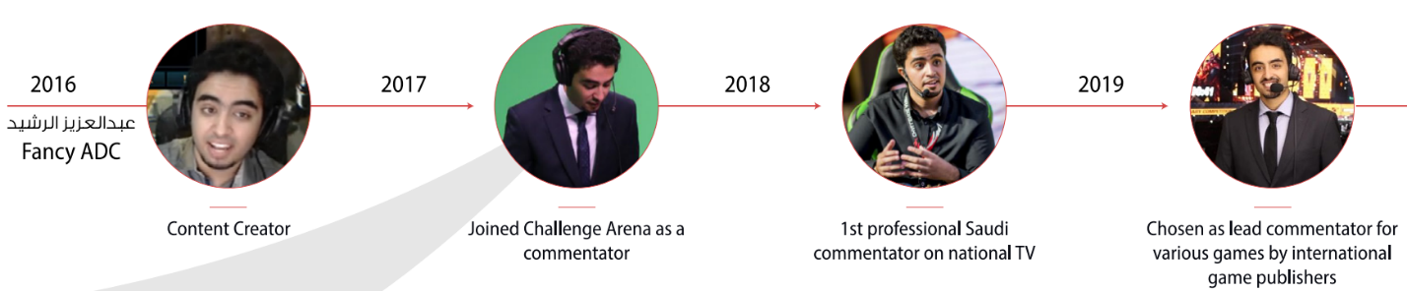

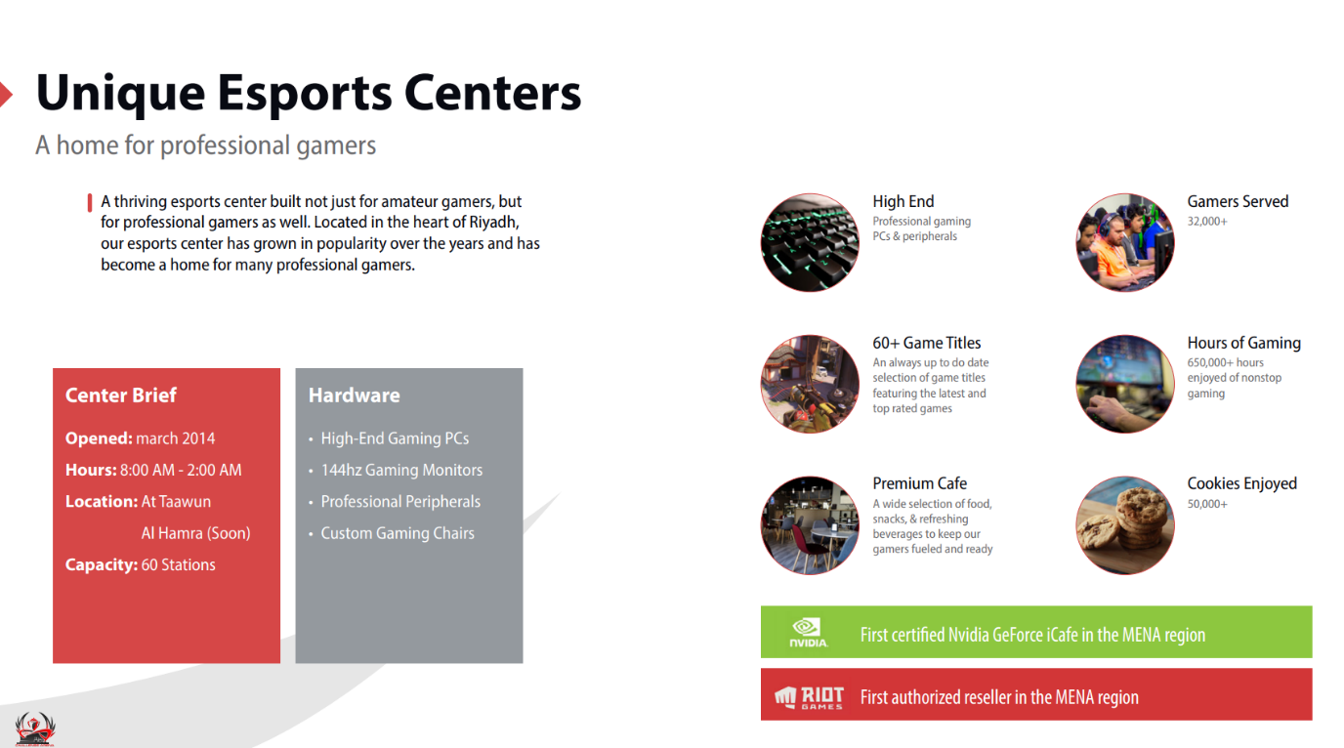

|  |
| --- |
| **STEP 3 Representative Positions.** |

* **Project Manager**

|  |
| --- |
| **STEP 4 Analyzes** |

**Project Manager Role: A Project Manager is responsible for planning, overseeing and leading projects from ideation through to completion. This is a senior role at an organization and requires interaction with a range of internal and external stakeholders, most often managing several moving project parts simultaneously.**

**Working Conditions: A Project Manager will face several work environments he might change teams in every project he works in so should now how to adapt in a new departments and be a good leader for the new work team, Communication skills are so important for a Project Manager because he is the one who will do the talking with the stakeholders. Should be efficient and a fast thinker be ready for anything wrong that could happen in the project.**

**Traits and Abilities:**

* **Writing and communication skills**

**A good communication will help to negotiate with the stakeholders and a good negotiation will give a clear picture to the stakeholder about what is going on this will also help to minimize the risk a good will written Email or meeting will keep the stakeholders happy and want to pursue in the project you are working in .**

* **Planning**

**The main core of a project manager job is to make good plan that will work in high quality and make revenue a good planning will achieve the goals that the company put to make all the stakeholders happy.**

* **Coaching**

**In every working team there will be a new employee or an intern that need to be coached with someone have experience, and there is no one like the project manager himself can coach better and give a good clear advices will help the new employee to grow faster and start to be productive as soon as possible.**

* **Staffing**

**Staffing is so sophisticated point how to know that this person will be productive and have the skill to actually do something in the project, with experience the project manager will develop maybe I can call it a sixth sense! Will help him to identify the good employee that who will help to grow better than the others. Not all project managers have this trait even with experience but to be a unique and good project manager focusing in this point will help to be different.**

* **Developing and tracking budgets**

**My analyzes shows that there are 3 steps for budgets tracking**

1. **Estimate the cost of the project: considering the experience to estimate the cost and time to deliver the project as example if the project will cost $35,000 and the budget is $25,000 the project manager should reconsider the options.**
2. **Get firm pricing: As a standard rule get three quotes to complete the work. However in larger organization you will have standard procurement guidelines that will specify how many quotes and in what form they need to be requests.**
3. **Consider contingency: Once you have received your quotes or proposal amounts, you then need to add contingency. To optimize the amount of contingency you allow for consider the major risks for the project and who is likely to be responsible. If you are responsible add an estimate for the likely work required as a separate item in your project budget.**

|  |
| --- |
| **STEP 5 Supervisor Verification** |

* **All the information the employee claim in the interview have been verified and approved by the manager.**

|  |
| --- |
| **STEP 6 Job Description And Specification** |

## **Job Title**

**Project Manager**

## **Reports To**

**Dr. Hussain Alqatifi**

## **Job Overview**

**responsible for planning, overseeing and leading projects from ideation through to completion. This is a senior role at an organization and requires interaction with a range of internal and external stakeholders, most often managing several moving project parts simultaneously.**

## **Responsibilities and Duties**

* **Leading Project planning sessions.**
* **Managing relationship with staff and stakeholders.**
* **Managing large and diverse teams.**
* **Ensuring projects meet deadlines.**
* **Secure growth opportunities and initiate new projects.**
* **Coordinating staff and internal resources.**

## **Qualifications**

* **Bachelor degree in management.**
* **5 years and more experience.**
* **Leadership Skills.**
* **Capacity to manage high stress situations.**
* **Big picture thinking and vision.**
* **Writing and communication skills.**
* **Ability to multitask and manage various project elements.**

|  |
| --- |
| **Interview** |

**In the following questionnaire all the answers are from the employee without any changes.**

|  |
| --- |
| **General** |

|  |  |
| --- | --- |
| **Name** | **Abdulaziz Suliman Alrsheed** |
| **Job Title** | **Project Manager** |
| **Department** | **High Level Management** |
| **What is the purpose of the job?** | **We are considered as a vendor we have a production company and operation. Whenever we got a client or a project I build the scope of work and make proposal or presentation to the client that fulfill his needs and wants operate the project.** |
| **What do you want to achieve? (Company)** | **There is a potential for E-Sports industry in MENA and that’s what I was trying to build individually before, when I know that the company also interested in building and developing the E-Sports industry I worked with them to achieve our end goal is to brought the international companies to invest and develop in the region ( with quality ).** |
| **Jobs under supervision** | **Project Management (Full time), casting and hosting ( part time ) and manage the freelancers employees in the projects.** |

**Organizational chart that shows the companies Abdulaziz worked with in projects:** 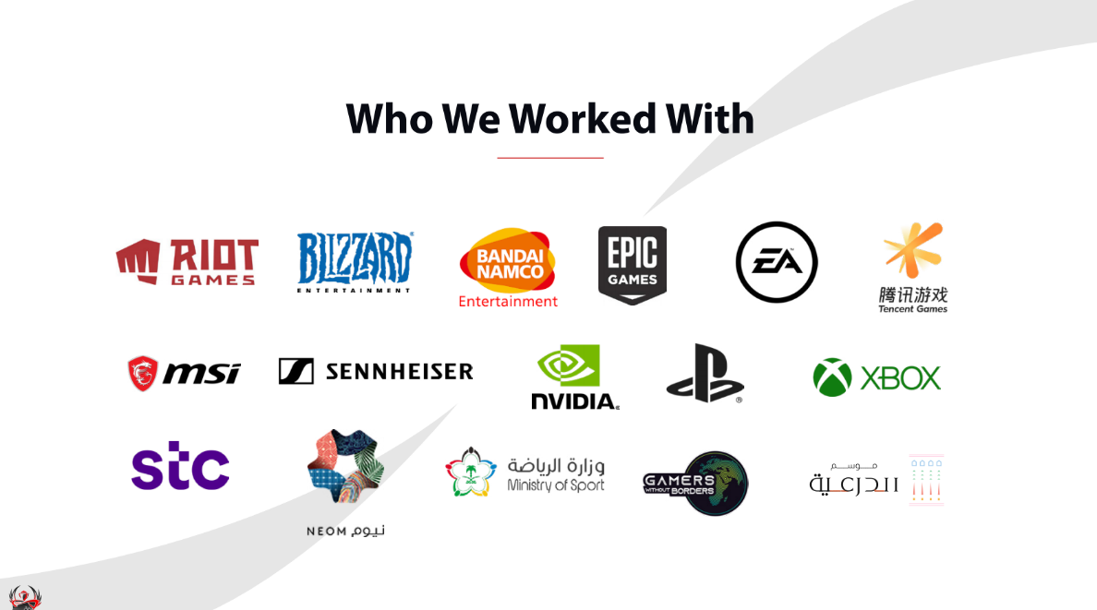

|  |
| --- |
| **Education And Experience** |

|  |
| --- |
| **Degree** |
| * **High school.** * **2 years software engineering (college drop out).** * **Winner of several software engineering awards across the kingdom.** |
| **Experience** |
| * **4-5 years casting and hosting in E-Sport.** * **4 years operation manager (Events, Tournaments and gaming café).** * **3 years project management.** |

|  |
| --- |
| **Work Conditions** |
| * **Fulfill client requirements.** * **Outsourcing if needed.** * **Staffing.** * **Coaching.** * **Manage the budget.** * **Meet deadlines.** * **Project proposals** * **Coordination between the client and company.** * **Deliver and operate the project.** * **Equip the equipment.** |

|  |
| --- |
| **Scope of Job** |

|  |  |  |  |
| --- | --- | --- | --- |
| **How much Supervision the role get?** | | **At the beginning there was checkup calls from the higher manager to keep him updated after a while I gain the trust from the board members about my work and how I do it so now I only report them with the result.** | |
| **How often do you report to your supervisor?** | | **I have the full responsibility for every project I work in they trust me and my decisions so no need to report my supervisor with every detail I just take on the work and give the full report and feedback at the end of every project.** | |
| **Documentation?** | | **Because we are small company the use of documentation is not that much whenever I have an issue or something to tell the managers and board members it can done by a meeting or phone call. Only documentation used when I need more budget for the project or in the end of every project, I report with the result, cost and everything in details** | |
| **Problem Solving** | |

|  |  |
| --- | --- |
| **What problems are you responsible of?** | **I am responsible in every problem with the projects starting with the freelancers, clients, equipment…etc. when it comes to the budget I have no control in it and not responsible with solving any.** |
| **Do you need an approval before you act?** | **Approvals needed only with the budget, any other matter I have the free of act to do what I think is right.** |
| * **Example of problem you solve**   **Once we had an event with STC in Riyadh Season they gave us a venue and we made a very cool things in the venue like come and play try video games PC’s are ready good Wifi It was a good experiment but we didn’t get a lot of visitors, so I talked to STC and told them about making a small daily tournament with small prizes they approved and they help us with the marketing all over the social media people starts to come and compete with each other and friends at the end of the day we announce the winner and give him the prize this lead to have more visitors and people know us as more.** | |

|  |
| --- |
| **Decision Making** |

|  |
| --- |
| * **Example of hard decision you made**   **We had a problem previously in the IAC project with Riot Games (client) we made content pieces as it is one of our scope of work like team montages and edits and we are good at it, they didn’t provide us a guidelines of how they want it to be done and they trust our decision and work.**  **What happen is that we always sent them a content pieces so we get the feedback and approval and they always say no it shouldn’t be like this and that, we finished a very good content piece and it took a lot of time and effort from the guys working on it then they rejected it and I told them we don’t have time the tournament will start in less than 24 hour and you didn’t provide any clear guidelines for the work so I will stick with this content pieces until you provide a guidelines to work with and the content piece wont be revised and this content piece will be used with the future content pieces make sure that you make the guidelines ready so we can work faster and better.**  **I consulted the managers before this decision because it is a big client and big decision and they agreed with me as a result now we have a guideline and we can work without waiting for there feedback.** |

|  |
| --- |
| **Other comments** |

|  |
| --- |
| **I wanted to talk about the working times I wanted to talk about because it is very different from the other companies, we don’t have working times in the company we made a working policy that no working times it depends on the productivity sometimes I need to work 3-4 hours as overtime so I can deliver the job and sometimes it passes 3-4 days without me being in the office, but whatever the job or task is we will get it done before the deadline no matter what that’s why sometimes you can come to the office at midnight and find me working on something it is not a working time but I have to deliver something or contact the client about something we have no delays in any of our projects and we always do everything and deliver it in high quality the feedback from the clients prove that.** |

|  |
| --- |
| **Reference** |
| **http://ca.sa/** |
| **https://www.topresume.com/career-advice/project-manager** |
| **https://www.roberthalf.com.au/employers/finance-accounting/project-manager-jobs#:~:text=A%20Project%20Manager%20is%20responsible,several%20moving%20project%20parts%20simultaneously.** |
| **https://www.businessinsider.com/esports-ecosystem-market-report** |